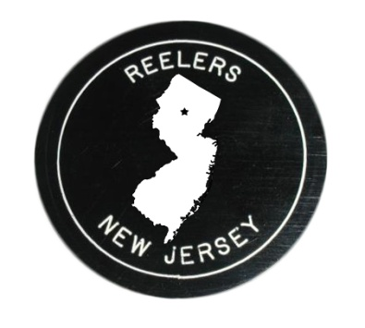  Info:  Bob Turner  973-216-4524  bvcturner@msn.com  reelers.nnjsda.org |  | REELERS  Plus/Mainstream Club with Rounds  Ironia School  303 Dover-Chester Road (Route 513)  Randolph, NJ 07869  1st and 3rd Fridays  7:30 Early Rounds 8:00-10:15 Plus/Mainstream/RD
For class info, call or text:
Square dancing (Plus and Mainstream): Mark Bippes, 973-476-8844, markbippes@yahoo.com
Round dancing at various levels: Mary Pickett, 908-419-3605
Cuer: Mary Pickett unless noted
2023-24 | Caller |  | Theme
09/15 | Mark Franks (NJ) |  | Welcome Back
09/29 | Dave Black (PA) |  | Wear Club Colors
10/06 | Ted Lizotte (NH) |  | Book and Puzzle Exchange
10/20 | Clay Goss (DE) |  | Autumn Festival
11/03 | Ed Foote (PA) |  | Polka Dot Party
11/17 | Sandy Corey (NY) |  | Give Thanks (food donations)
12/01 | Ken Ritucci (MA) |  | Books for Kids (new books)
12/15 | Dayle Hodge (MD) |  | Holiday Cookies
01/05 | Doug Kauffman (NJ) |  | Treasure Hunt
01/19 | Jenn Engimann (PA) |  | Denim and Diamonds
02/02 | Mark Franks (NJ) |  | Souper Bowl (bring canned soup)
02/16¹ | Paul Ingis (NJ) |  | Presidents and Pies
03/01 | Dan Koft (PA) – Kathy cuing |  | Wearin’ of the Green
03/15² | Dane Bragg (PA) |  | Welcome, Plus Students
04/05³ | Howard Richman (NJ) |  | Name Yourself
04/19⁴ | Clay Goss (DE) |  | Treasurers’ Break
05/03 | Rick Gittelman (AZ) |  | Chocolate Decadence
05/17 | Ed Foote (PA) |  | Ice Cream Social
05/31⁵ | Jenn Engimann (PA) |  | Graduation Gala
¹Union Hill Church, 427 Franklin Road, Denville
²Student Plus, no rounds
³Randolph High School, 511 Millbrook Avenue, Randolph
⁴NNJSDA club treasurers free; check email for possible change in location
⁵Added 5th Friday dance; no June dance

