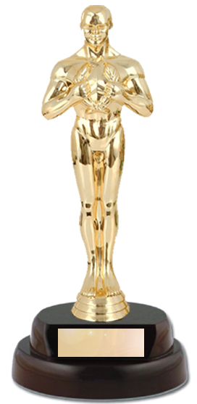
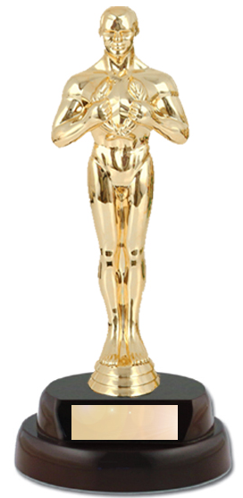

On Monday, June 10, 2024
8:00 to 10:00 P.M.

LAKELAND SQUARES
PRESENTS

The Nineteenth Annual
“A NIGHT AT THE MOVIES”

WITH YOUR HOST
HOWARD RICHMAN

Join our salute to Hollywood, a star-studded evening!
New graduates and members of other clubs most welcome.

Come in Costume (or not - audience members needed too!) and join us in honoring our favorite movies and movie stars, movie animals or cartoons. Winning dancers will receive awards.

Alternating Mainstream and Plus
at
Church of the Good Shepherd
9 Two Bridges Rd. Towaco, NJ 07082

AIR-CONDITIONED HALL

Vaccinations and masks not required, but optional.

To Contact us:
Call Kathy: (973) 973-229-0698 (c)
Call Monte/Janet: (973) 546-3092
E-mail: LakelandSquares@hotmail.com
Website: http://www.lakelandsquares.wix.com/lakeland

